***Two-Wheeler Repair & Maintenance***

***MicroProject***

***Topic: Head lamp and Tail lamp of motorcycle***

A headlamp is a lamp attached to the front of a vehicle to illuminate the road ahead. Headlamps are also often called headlights, but in the most precise usage, headlamp is the term for the device itself and headlight is the term for the beam of light produced and distributed by the device. It doesn’t take a lot of tools to replace the headlight on a motorcycle

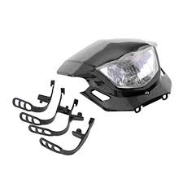

Following are the steps of replacing the head light :

**Step 1 – Secure Motorcycle**

Be sure that your motorcycle is on level ground and is balanced well on its kickstand. Having a malfunctioning headlight will be the least of your worries if your motorcycle falls over on you while you’re working on it!

**Step 2 – Remove screws**

Remove the two screws that are placed on either side of the headlight lens unit with a screwdriver. You can gain access to the headlight by opening the casing it’s enclosed in.

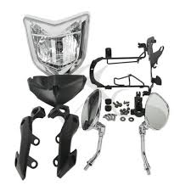

**Step 3 – Detach Headlight Coupler**

Detach the headlight coupler so that you can take off the bulb cover. The headlight coupler is a piece on the back of your bulb cover where the leads connect. Detach the bulb holder to gain access to the bulb.

**Step 4 – Remove Burned out Bulb**

Unscrew the malfunctioning bulb. It might be hot, so be careful.

**Step 5 – Put in the New Bulb**

Screw in your replacement bulb and put the bulb cover back in place.

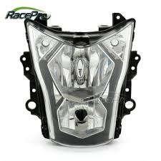

**Step 6 – Reconnect**

Reconnect both the headlight bulb cover and the coupler that you removed previously. Screw the headlight lens unit back into place securely.

**Step 7 – Test**

Test the new bulb to be sure it works.

**Tail lamp**

Tail lamp can be defined as the lighting system of a motorcycle at the rear side. ... Nowadays most of the motorcycles contain LED tail lamps.

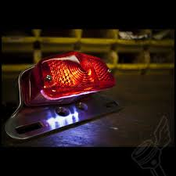

Steps to replace the tail lamp of the motorcycle:-

#### Step 1 - Accessing the Wires

Start by using your Phillips head screwdriver to remove the motorcycle tail light lens from the fender. Set it aside carefully with the screws. You will now have access to the old bulb and the bulb housing.

Without removing the bulb from the housing, pull the bulb housing out of the fender so the bulb hangs free and the wires are exposed. Keeping the bulb in place will allow you to test the wires.

#### Step 2 - Testing the Wires

Next, you need to test the wires in order to know which of the wires goes to the brakes, the running lights and the turning signals. This will enable you to wire the LED bulb correctly. To do this, with the engine running, you will need to probe each wire with the 12 volt test light. Start by pulling on the brakes to see which wire causes the test light to glow. Run through until you’ve established which wire is responsible for each individual function. You should make a note or mark each wire with tape to avoid any confusion.

#### Step 3 - Wiring

Before you go further, check to be sure that your new LED housing with accept blue butt connectors with no problem. In most cases there should be no problem with this. Now, with the wires tested, you can cut back each of the wires behind the bulb housing and strip the end of each one for short distance; you probably won’t have too much wire to play with so don't be too liberal with your cutting. With the wire crimper, crimp the end of each wire to a blue butt connector. From there, you can use the blue butt connectors to connect the wires to the LED housing. Finally you should check again to be certain that you have the wires connected correctly; checking now can save you having to disassemble everything later.

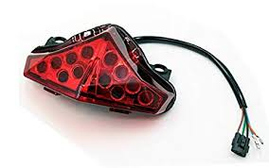

#### Step 4 - Mounting

With the housing correctly wired, you are now ready to mount it back onto the fender. It should mount exactly the same way as a regular motorcycle tail light. Screw the motorcycle tail light lens back in place and test the lights to be certain they work properly.

Testing before you hit the road is vital. You don’t want to be driving only to realize that your motorcycle tail lights aren’t working.